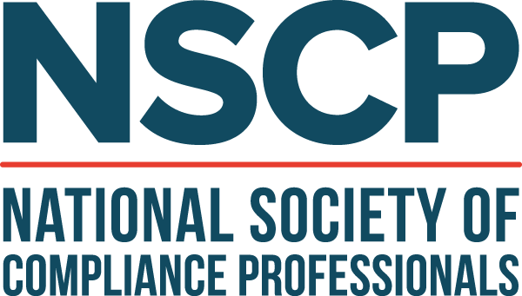

Dear {insert name},

The National Society of Compliance Professionals is a professional membership organization for compliance professionals in the financial services industry. They offer a wide range of compliance resources and continuing education opportunities, providing individuals with essential information on industry topics and regulatory insights. NSCP’s National Conference is coming up, and I would like to participate in this engaging and important event.

At NSCP’s National Conference, I will have the opportunity to hear from SEC and FINRA regulators, including a SEC Commissioner. I will be able to attend up to ten comprehensive educational sessions including labs and talk groups, providing practical takeaways, best practices, and new insights that I can bring back to our team. I’ll get updated information on subjects such as: [insert key session topics you plan to attend]. I will also have opportunities to earn continuing education credits while at the conference. Most importantly, I’ll gain a better understanding of the rules and regulatory requirements associated with my role. I’ll receive important resources, practical templates, and useful tools that I can use to ensure {insert your organization name} is complying with updated regulations and industry standards.

I will also have the invaluable opportunity to connect with not only other compliance professionals, but exhibitors, too. I will be able to see firsthand what solutions are out there for our team, and have important discussions with individuals, leaders, and experts across the compliance and legal fields. By networking and connecting with attendees, speakers, industry leaders, and exhibitors, I will leave NSCP’s conference with valuable tools, resources, and opportunities for our company.

This event will take place in Dallas from October 27-30, 2024, at the Omni Dallas.

Conference Registration  *This includes access to all education sessions, networking opportunities, meals, and the exhibit hall. | $
Accommodations estimate ($275/night + taxes) | $
Flight estimate | $
Total | $

​​My attendance at NSCP’s National Conference will greatly benefit both me and our organization. Once I return, I can provide a report of my key takeaways, and share new resources and strategies with the team. I will work hard to ensure we get the full value of this event. Thank you for your consideration.

Sincerely,
{your name}

